Title:

Effects of short-interval disturbances continue to accumulate, overwhelming variability in local resilience

Katherine Hayes1, Brian Buma1

Author Affiliations:

1University of Colorado Denver, Department of Integrative Biology

* Correspondence to katherine.hayes@ucdenver.edu

Abstract:

Increasing rates of short-interval disturbances have the potential to rapidly transform ecosystems via shifts in post-disturbance regeneration. While research has explored compound events in multiple biomes, we know little regarding how local site conditions interact with short-interval disturbances to influence post-disturbance regeneration. Furthermore, questions remain regarding the consequences of continued high frequency events – what happens when emerging new communities are themselves subject to short-interval disturbances? To investigate effects of ongoing short-interval fires on regeneration, we examined post-fire forest regeneration in two locations in Interior Alaska. We established 50 plots across a mosaic of fire histories (1, 2 or 3 fires in <70 years) in an upland and lowland site in Interior Alaska. To investigate how shifts in community driven by short-interval fires differ according to local site conditions, we quantified abundance, proportion and density of conifer and deciduous regeneration in a drier upland site and a wetter lowland site. Both sites were dominated by black spruce prior to burning. In the drier upland site, black spruce (*Picea mariana*) presence declined sharply after two fires while paper birch (*Betula neoalaskana*) became increasingly abundant with each additional fire. In the wetter lowland site, less organic soil was consumed by fire and presence of black spruce persisted through an initial single reburn (two fires), indicating local topography may temporarily buffer reburning impacts. However, after three burns, conifers were effectively eliminated in both upland and lowland stands. Deciduous regeneration differed with site: birch dominated in upland plots while willow (*Salix* spp*.)* and aspen (*Populus tremuloides*) dominated in lowlands. These results offer strong empirical evidence of the divergence of boreal successional trajectories from previous historic norms. Furthermore, results from this study demonstrate shifts in postfire succession in forested ecosystems continue to accumulate with additional short-interval disturbance events, overwhelming the interactive effects of local site conditions.

**Keywords:** boreal, ecosystem transformation, fire frequency, reburns, regime shifts, succession

# Introduction

Disturbances are a major driver of community composition and biomass, and in many ecosystems are the major force that create and maintain ecosystems themselves (e.g., grassland or forests, Dantas et al. 2016). Theory suggests that in disturbance-adapted systems, communities can recover via resilience mechanisms after even intense disturbances (“ecological memory,” Johnstone et al. 2016). Here, the capacity for ecological resilience refers to the degree of disturbance a system or community can absorb without undergoing meaningful transformational change (i.e., shifting into an alternate state; Holling 1973, Pickett et al. 1989), and resilience mechanisms refer to the system or species-specific characteristics that promote a return to pre-disturbance state. In this context, if additional disturbance events occur within the timeframe of recovery, resilience mechanisms can be overwhelmed, enabling irreversible population collapse and subsequent “ecological surprises” (Paine et al. 1998): recovery trajectories not easily predictable from knowledge of the individual disturbance agents themselves (Scheffer and Carpenter 2003, Buma 2015). Examples abound, both terrestrial and aquatic – from changes in bamboo communities after fires and floods (Gagnon 2009), coral reef phase shifts after fishing and hurricanes (Hughes 1994), and experimental aquatic mesocosm studies (Kercher and Zedler 2004). Long-term shifts to different disturbance regimes (e.g., higher frequency) or other feedbacks can allow new community types to persist, driving fundamental shifts in ecosystem structure (e.g., grazing and fires, Archibald et al. 2005; coral reef functioning, Jones et al. 2004). Theoretical modeling agrees, and further suggests changes in disturbance frequency are more important than changes to severity or other disturbance characteristics (Fraterrigo et al. 2020) in driving variability in recovery.

Research into the effects of disturbance frequency changes have almost exclusively focused on high severity disturbances and single short-interval events (two disturbances). This limits our understanding of the ongoing effects of continued short-interval disturbances. While modeling suggests progressive loss in ecosystem functions (e.g., ongoing fires in Yellowstone, Westerling et al. 2011), it is also true that subsequent disturbances interact with previous disturbance conditions, changing severity and overall impacts which can limit future disturbance severity or even occurrence (Parks et al. 2015, Buma et al. 2020). Trajectories inferred from single short-interval events may therefore not be valid if frequency of disturbances remains high. In addition, effects on ecosystems are mediated by external factors, such as topography and local site conditions, which theoretically may modulate cumulative impacts (Paine et al. 1998). However, if frequency is truly the most significant factor (Fraterrigo et al. 2020) then that moderation effect should disappear with ongoing events. This too has not been empirically investigated.

This study tests theoretical outcomes of continued short-interval disturbance effects directly in a disturbance adapted biome by examining 1, 2 or 3 events occurring in short-interval across two topographic contexts with known differences in resiliency via local site conditions. We use fires and boreal forests as our test system. Boreal forests are globally significant in terms of permafrost (Mann et al. 2012) and carbon stocks (Alexander et al. 2012) and are highly fire adapted and warming rapidly, meaning they are ideal to test theory related to changes in disturbance frequency, multiple disturbances, and ecosystem resilience. Boreal fire return intervals were historically >100 years in Interior Alaska (Yarie 1981, Viereck 1983, Johnstone et al. 2010). These forests are highly resilient to fire via self-replacement successional pathways (Kurkowski et al. 2008, Ott et al. 2006), and here we quantify resilience with that metric – regeneration densities and areas. The dominant conifer, black spruce (*Picea mariana*), typically self-replaces within 5-10 years via a large canopy seedbank after fire (Greene et al. 2013, Kurkowski et al. 2008, Johnstone et al. 2004).

Self-replacement is enabled by 2 primary factors: species-specific regeneration traits (including dispersal distances and seed size) and local soil characteristics. Prior research suggests the interaction between short-interval fires, species regeneration traits and soil characteristics may lead to widespread community conversion of black spruce forests via the following processes: first, loss of aerial seedbanks through repeat short-interval burning can favor wind-dispersed species with longer dispersal distances (e.g., 80m for black spruce vs. several kilometers for aspen or birch; McCaughey et al. 1985, Marquis et al. 1969, Burns and Honkala 1990), which can better colonize from outside burn perimeters (Brown and Johnstone 2012). Additionally, short-interval burns can consume deep layers of organic soil and *Sphagnum* mosses, providing greater exposed mineral soil surface which may enhance germination rates. Aspen (*Populus tremuloides;* Greene and Johnson 1999*)* and birch (*Betula neoalaskana;* Zasada 1971) produce large quantities of small wind-borne seeds (Roland et al. 2009, Greene et al. 2007), which may benefit from the interaction of limited black spruce seed availability and greater available mineral soil surface, depending on the amount of substrate consumed during fire (Hesketh et al. 2009). Models suggest that the interaction of seedbank and soil consumption driven by short-interval fires will lead to a shift in local community composition from conifer-dominated stands to deciduous forest (Mann et al. 2012, Roland et al. 2019, Rupp et al. 2002) or grassland (Brooks et al. 2004, Roland et al. 2013).

The definition of short interval fires varies by study (e.g., 5 or 25 years, Buma et al. 2020, Fairman et al. 2019; 50 years McRae et al. 2006, 30 years Turner et al. 2019), but for the boreal forest can be functionally defined as when second (or third) fires occur prior to the time required to regenerate the local serotinous seedbanks, extirpating local populations and facilitating rapid forest type conversion (Buma et al. Here we investigate fire return intervals from 12 –30 years (see Methods, Table S1) and define short interval fires for discussion purposes within this region as <50 years given system-specific research that suggests 50 years or more are required for full aerial seedbank regeneration (Johnstone et al. 2004).

Ecosystem transitions (from black spruce to deciduous species) following two consecutive, short-interval fires have been well documented in Interior Alaska (Johnstone et al. 2004), the Yukon Territory (Brown et al. 2015, Whitman et al. 2018), Eastern Canada (Bergeron and Fenton 2012) and Northern Minnesota (Camill and Clark 2000, Frelich et al. 2017). However, the two key limitations mentioned above apply. First, we do not know if those emerging communities are themselves resilient to ongoing short-interval fires (in other words, what happens when a deciduous forest reburns within a short interval?). To our knowledge, there are no studies examining 3 burns in short succession, despite the fact that overall increases in fire frequency can be expected to facilitate continued and ongoing short-interval burning. Second, previous studies on short-interval fires in boreal Interior Alaska are primarily in gently sloped upland environments (i.e., Gibson et al. 2016, Houle et al. 2017) where fires are generally high intensity, so the impact of short-interval fires in more inherently resilient topographic contexts is unknown. The under-examination of reburns in lowlands compared to uplands may be partially due to the historic unlikelihood of lowlands burning (Le Goff and Sirois 2004, Whitman et al. 2019, Alexander and Mack 2015), though they represent a substantial fraction of the biome (~42% in interior Alaska, Douglas et al. 2014). Despite having the same ecological community, higher soil moisture in lowland areas may provide a mechanism of resilience to soil consumption. Investigating short-interval fires in understudied lowlands will not only contribute to our understanding of the scale of landscape transformation in the boreal, it will also inform expectations regarding whether continued accrual of disturbances at frequencies higher than historic norms will eventually overwhelm even the more resilient topographic positions, “homogenizing” previously variable locations.

This study characterizes post-fire regeneration of tree species in upland and lowland stands across a gradient of 0, 1, 2 or 3 fires since 1940 occurring via a rapid increase in fire frequency in boreal interior Alaska. We ask the following research questions: 1) what is the impact of ongoing short-interval reburning in boreal forests?, 2) is the effect of short-interval reburning on soil consumptions mediated in wetter, potentially more resilient lowland locations? and 3) does local landscape position interact with continued reburning to influence the dynamics of conifer and deciduous regeneration? We hypothesize the following: initial short-interval fires will reduce conifer regeneration and favor deciduous regeneration in uplands, and repeat burning (3 fires in sequence in short intervals) will push historically-resilient lowland stands toward the same outcome. Given the evidence that short interval fires can trigger ecosystem regime shifts from coniferous to deciduous systems (Johnstone et al. 2011, Brooks et al. 2004, Hoy et al. 2016), understanding the *ongoing* effects of multiple short-interval fires, especially in regenerating deciduous stands, is essential to understanding and predicting environmental and climatic change.

# Methods

## Site Selection

To investigate these questions, we worked in the boreal forest of interior Alaska. We established 50 20x20m plots in the summers of 2018 and 2019 between an upland and lowland location in Interior Alaska in pre-fire black spruce forest types (Fig. 1). Plots were randomly placed within described burn histories, an average of 4.7 km apart (minimum 90 meters, maximum 13 km, median 4.19 km) and a minimum of 100 meters away from unburned legacies to control for black spruce dispersal distances.

Using historical aerial photographs, burn history (Alaska Large Fire Database, FRAMES, 2018), and modern remotely sensed fire perimeters (Monitoring Trends in Burn Severity database, MTBS), we identified pre-fire mature black spruce stands that experienced one to three severe (complete aboveground mortality) fires in the last 60 years; all stands underwent the final burn in 2003-2006 (Table S1). Plots represented four specific reburn histories: 1) mature unburned black spruce forest stands (n = 8; Fig. 2A), 2) once-burned black spruce forest recovering from a single recent (>50 years) fire (n = 15, ~15-16 years ago, Fig. 2B), 3) twice-burned black spruce forest recovering from two short-interval fires (n = 15, one ~15-16 years ago, and the second ~30-50 years ago, Fig. 2C), and 4) thrice-burned black spruce forest (n = 12, burned once ~15-16 years ago, a second time ~30-50 years ago and finally a third ~45-70 years ago; Fig. 2D). For the earliest fires, pre-fire composition and complete aboveground mortality at a plot was inferred via the historical photographs and verified via wood anatomy/tree ages (to ground-truth initial spruce dominance and no survivors from previous fires; data not shown). Fires were of comparable size ­ (Table S1). All burned plots were sampled 12-15 years postfire.

## Field Sampling

To determine the impact of repeat short-interval fires on conifer and deciduous post-fire regeneration, we surveyed density, basal area and species composition of tree species on each plot. We recorded species, diameter, and condition (live or dead) of all individuals above diameter at breast height (DBH; 1.37 meters). Where density precluded counting over the entire 400 m2, we counted a randomly selected subset (100 or 200 m2) and scaled accordingly. We recorded presence, species and condition of seedlings that fell below 1.37 meters across ten 1-m2 sections randomly placed on each plot. We counted asexual reproducers like willow and aspen, as one individual in our density estimates and as separate individuals in our basal area estimates in order to avoid overestimating abundance of regeneration events, while still accounting for the biomass of regeneration present on a plot. Tree and seedling counts were pooled in this study to focus on broad-scale trends in regeneration.

We calculated three metrics of regeneration: 1) density (number of stems per hectare), 2) basal area (square meters per hectare) and 3) the relative proportion of species present within a plot (number of stems of a species present / number of stems of all species present). The drivers and implications of changes in tree density, tree basal area and tree proportion are distinct and meaningful: we used stem density to represent an important characteristic of post-fire stand structure, basal area to describe trends in overall biomass and tree size and the proportion of tree species present on a plot to capture stand-level patterns in post-fire tree community composition.

To characterize soil characteristics across the burn histories, we evaluated organic layer depth and percent cover of exposed mineral soil. Organic layer depth was measured at the center and at each corner of each plot. Percent cover of organic and exposed mineral soil surfaces were estimated across 1-meter subplots at each corner of each site. To infer soil consumption in the most recent fire, distance from adventitious roots (opportunistic, lateral roots produced after initial root system development) to current soil surface was measured where snags with such roots were available to sample following the approach of Kasischke and Johnstone 2005 (data presented in supplement).

## Data Analysis

To investigate the interactive effects of short-interval fires and landscape position on conifer and deciduous regeneration, we created a series of generalized linear models to model both density and basal area of conifer and deciduous regeneration. To investigate whether the effects of fire interacted with topographic position to influence regeneration, we evaluated the strength of an interaction term between fire and topographic position in each model. We used negative binomial regression with a log link function to model conifer and deciduous density, given its effectiveness in modeling overdispersed ecological count data (Lindén and Mäntyniemi 2011).We used a gamma distribution with a log link function to model basal area of deciduous species (conifer species had insufficient basal area present in reburned plots to model).

Topographic attributes like slope, solar radiation and elevation have well-documented roles in shaping site-level community composition (Hollingsworth et al. 2013). Based on the presumed role of slope in altering local drainage conditions between upland and lowland topographic positions, we tested adding slope (USGS 2019; 5m resolution) as a variable and evaluated subsequent model fit using lowest AIC values (reported with other goodness of fit metrics in Table S5). Elevation and annual solar radiation, while important factors driving tree composition in Alaska, were ultimately not included as a variable since neither varied meaningfully across plots (Fig. We evaluated the importance of each variable by comparing the cumulative evidence provided by effect sizes, standard errors and confidence intervals. All GLMs were built using the ‘MASS’ package (Venables and Ripley 202) and all analysis, model fit, and selection were performed in R version 3.5.2 (R Core Team, 2018). Reported means include standard errors.

Because our plots are clustered by design to take advantage of natural experimental -conditions, spatial autocorrelation in density and basal area among plots was assessed using Moran’s I (Moran 1950) (Table S3).

# Results

Unburned plots were dominated by black spruce. Unburned upland plots had larger individual conifers, as reflected by greater overall basal area (mean 0.28 m2/ha, SE 0.02), while lowland unburned plots had greater density of conifers (mean 13,057 stems/ha, SE 5147). Deciduous species were largely absent from unburned plots (Fig.

## Patterns in post-fire regeneration

Density of regeneration of all species was greatest after one fire and declines in both sites with additional reburning. In both sites, conifer stem density increases after one fire: upland conifer stem density increased 7x after one fire (relative to unburned plots) and lowland conifer stem density increased 4x after one fire (Fig. 4). However, patterns of conifer density in the two sites diverged with additional reburning: upland conifer density declined by a factor of 4x after two fires (relative to the single burn plots) and by 16x after three fires (relative to the twice burned plots). In lowlands, conifer density continued to increase by a factor of 1x after the second (relative to once-burned plots), before declining by a factor of 32x after three fires (relative to twice-burned plots). Density of deciduous species increased in both sites after on fire: by a factor of 164x after one fire in upland plots (relative to unburned plots), and by a factor of 195x after one fire in the lowland site (relative to unburned plots). In upland plots, deciduous density then declined by a factor of 2x after two fires (relative to once-burned plots) and continued to decline by an additional 2x after three (relative to twice-burned plots). In lowland plots, deciduous density increased by a factor of 3x after two fires (relative to once-burned plots) and by a factor of 2x after three fires (relative to twice-burned plots), a slower trend compared to upland plots (for numerical values, see Fig. 4).

Regeneration of basal area followed a similar trend: after one fire, deciduous basal area declines by a factor of 24x in uplands and by a factor of 20x in lowlands (compared with respective unburned plots). Deciduous basal area then increases by a factor of 15x in upland plots but declines by a factor of 2x in lowland plots, relative to respective once-burned plots in each site. After three fires, deciduous basal area increases by a factor of 2x in upland plots and by 2x in lowlands, compared to twice-burned plots (Fig. 5).

Composition of all burned plots was primarily deciduous species, but the specific species present differed between upland and lowland sites (Fig. 6). Once-, twice- and thrice-burned lowland regeneration was predominantlywillow (29%, 55%, and 58% respectively) with aspen emerging after the third burn (24%). Regeneration in burned upland plots differed across reburn sequence: willow presence declined across reburn while birch presence increased to 63% by three fires (Table S4).

## Post-fire soil characteristics

On average, lowland organic layers were twice thicker than upland layers regardless of number of reburns. The difference between the two topographic positions was largest in twice-burned plots where lowland organic-layers were 3 times larger on average (Fig. 7). The decline in organic layer depth occurred faster in upland plots than in lowland plots: organic layers were reduced by a factor of 3x after one fire in upland plots (relative to unburned plots), but only by a factor of 2x in lowland plots (Fig. 7B). After two fires, upland organic layers were smaller by a factor of 2x relative to once-burned sites, while lowland organic layers were smaller by an average factor of 1x. After three fires, average upland organic layers were 2 times smaller compared to twice-burned counterparts, while lowland organic layers were smaller by a factor of 3x, indicating more organic soil layer was consumed in the third fire in lowland plots. Similar trends exist in exposed mineral soil: upland plots had no exposed mineral soil in unburned plots but saw an increase in the amount of exposed mineral soil, up to 100% in some thrice-burned plots (Fig. 7C). Less exposed mineral soil was present in lowland plots, potentially because of higher grass cover (data not shown).

Interactive effects of fire and topographic position on ***conifer and deciduous regeneration***

The most predictive model of density of regeneration of both conifer and deciduous species included only number of fires and topographic position as variables with an additional interaction term between the two. Including slope as an additional variable marginally improved model fit of deciduous basal area, as indicated by AIC value (Table S5).

The effect of fire on regeneration varied between topographic position and between conifer and deciduous species. As expected, fire decreased density of conifer regeneration, but specific reburns had different effects: three fires had a greater effect size (effect size -4.8 log conifer density per fire, SE 0.59) than two fires (-2.52, SE 0.55) (Table 1). Fire had negative effects on deciduous density, stronger after three fires (-1.45, SE 0.5) than after two (-0.8, SE 0.55) (Table 1). Both the second fire and the third had positive effects on deciduous basal area (1.77 log basal area per fire, SE 0.44; and 2.98, SE 0.50 respectively) (Table 2).

The strength of the interactive effect between fire and topographic position differed according to the metric of regeneration and according to the fire. Two fires interacted with topographic position strongly to influence conifer density (effect size 2.6, SE 0.82), while the effect of interaction between three fires and topographic position on conifer density was slightly weaker (1.47, SE 0.83) (Table 1). The inverse relationship existed between the interaction between fire and topographic position and deciduous density: the effect size of two fires interacting with position was 1.84 (SE 0.82), while the effect of three interacting with position was 2.0 (SE 0.83). Deciduous basal area was strongly impacted by the effect of two fires interacting with topographic position (-1.64, SE 0.61), but less impacted by the interaction of three fires and position, given the large standard error (-0.77, SE 0.69).

# Discussion

Using novel empirical evidence of 3 fires in short sequence, we show that reburning-triggered shifts in forest composition and structure continue beyond two fires and that new effects begin to emerge with three short-interval fires. Our results suggest that the transition from conifer to deciduous species documented by Brown and Johnstone 2012 and others (Beck et al. 2011, Hoy et al. 2016, Johnstone et al. 2010) continues to occur with additional fires. Furthermore, specific species composition within deciduous trajectories differed between topographic position, indicating the importance of local topography in filtering specific successional outcomes. Our results suggest that not only can topographic position interact with reburning to alter post-fire trajectories but that 3 reburns in sequence appears to disrupt self-replacement trajectories even in a historically resilient topographical context.

Conifer regeneration declined with reburning in favor of deciduous species. These results are consistent with trends reported in Brown and Johnstone 2012 and others, who have documented a sharp decline in conifer regeneration following two fires in short sequence (I.e., Whitman et al. 2019, Johnstone and Chapin 2006). However, the extent of conifer population collapse documented in this study surpasses that reported in Johnstone et al. 2014 and others: Whitman et al. 2019 reported conifer regeneration in plots burned under short intervals (<17 years) declined by a factor of 2x compared to plots burned under more typical intervals (>30 years), similar to our finding that conifer recruitment declined by a factor of 3.7x after 2 fires in upland plots. However, while others have documented widespread extirpation of conifer regeneration after two fires in short-intervals, hinting at a regime shift, previous studies examine only the effects of a single reburn event, and are limited in their ability to address the question of ongoing burning.We confirm that here that ongoing burning continues to change regeneration of both conifer and deciduous species, particularly even in potentially more resilient lowlands. A study of single reburn events in lowland forests might capture the demonstrated slower decline in conifer regeneration and presume that lowlands might be more resilient to short-interval burning*.* Our results indicate that accounting for the effects of short-interval disturbances across heterogenous landscapes like Interior Alaska requires examining ongoing change.

Post-fire soil characteristics differed between topographic contexts as hypothesized: uplands had substantially thinner organic layers and more exposed mineral soil than lowlands, but organic layer thickness decreased with greater burn frequency in both locations. Given the well-documented role of burn severity in altering competitive dynamics between coniferous and deciduous species in the North American boreal (Johnstone and Chapin 2006, Whitman et al. 2018), this variation between topographic position indicates that black spruce may retain competitive advantage longer in lowlands under single fires or reburn events. However, lowland plots still underwent a transition to deciduous communities linked with a removal of organic layers, indicating potential resilience via initially lower soil consumption (implying lower fire intensity) is limited and that, as predicted by theory, frequency of events is as important as any disturbance characteristic in driving recovery trajectories (Fraterrigo 2020).

Post-fire stand characteristics differed across reburn sequence and between topographic position. Tree density and basal area were consistently higher in upland stands than lowland counterparts. Greater exposed mineral soil lead to greater deciduous basal area but reduced deciduous densities, indicating a more open stand structure with larger individual trees. A shift in stand structure (via changes to stand density) may alter landscape characteristics like aboveground carbon storage and landscape flammability. Given that fuel will play a central role in ongoing boreal fire regime change, understanding the influence of altered stand structure on local fuel loads and structure will be crucial to managing and predicting future fire behavior (Higuera et al. 2008).

The shift from conifer to deciduous species occurred differently in upland and lowland sites: upland reburned plots were composed of willow and birch in higher abundance and densities than comparable lowland plots and experienced a decline in black spruce earlier in the reburn sequence. Black spruce populations declined slower in lowland plots and were replaced by aspenand willow after three fires. This divergence suggests that both site-level differences in drainage conditions and reburning effects play an important initial role in determining species-specific successional outcomes in boreal forests – but that the effects of reburning continue to accrue after the 2nd event. Additionally, species-specific reproductive traits like asexual reproduction may play an important role, which this study does not address.

These results are limited in spatial and temporal scale in two major ways: one, our assessment of forest regeneration occurs 15-16 years post-fire, resting on the assumption that early recruitment dynamics in boreal Alaskan forests remain sufficiently predictive of future composition. The eventual composition of these specific sites will remain to be seen, as even low densities of black spruce (for example) can infill if the interval between fires is long enough. However, the bulk of evidence provided by Johnstone and Chapin 2006 and others indicate that early patterns of regeneration in the boreal tend to be highly prescriptive of multidecadal successional trajectories. Furthermore, the spatial extent of larger ecosystem transition in the boreal remains unknown: emerging deciduous communities appear to be spatially constrained within fire or reburn perimeters (Roland et al. 2019). The results of this study are similarly limited in scale. However, we contribute to the growing body of evidence of site-level successional trajectory disruption via short-interval reburns.

Our work presents several key inferences relevant to boreal forest ecology and disturbance theory generally. First, low quantities of black spruce seedlings in twice- and thrice-burned plots suggests a potential local extirpation of black spruce seed sources, preventing future self-replacement. Second, organic soil layers in both sites were consumed during each reburn, even in the wetter lowland site, leading to increased exposure of mineral soil surfaces. Finally, deciduous communities emerged in both upland and lowland sites, replacing original black spruce communities entirely. Together, these patterns suggest that short interval fires lead to meaningful disruption of existing successional trends despite proposed local resiliency within poorly drained lowland conditions, and that repeat burning in emerging deciduous post-fire communities not only can occur but continues to drive community shifts towards dominance of deciduous trees and shrubs partly facilitated by removal of organic soil layers and surfaces. Results from this study have broad implications for transitions and trajectories of both coniferous and deciduous boreal forests under climate change, as it appears the widely anticipated reduction in fire return intervals will continue to change forest structure and function beyond initial short-interval effects and regardless of initial local resiliency.

# Conclusions

The effects of more frequent disturbances do not stop with the first ecosystem transition, recovering communities themselves can be transformed by ongoing short-interval events. Further, high frequency disturbances can drive transitions even if those occur with lower intensity. For boreal forests, successional trajectories can quickly become untethered from regional legacy conditions. Ongoing transformations are more in line with primary successional pathways then secondary, and while wetter lowland forests are initially more resistant to ecosystem transitions, that resilience is overcome by subsequent fires. The unique perspective of this study demonstrates current shifts in disturbance regimes continue to drive quantitatively different outcomes compared to single, short-interval events, and therefore questions regarding resilience to future climate effects must explicitly consider unfolding, emerging, and ongoing changes, not just snapshots in time.

# Acknowledgements

This research was supported by funding provided by the National Science Foundation (NSF-OPP-1903231). We thank Kristin Olson, Vishnusai Kodicherla, Kyle Martini and Kyle Turchick for assistance in the field and to Shelby Weiss, Adrienne Marshall, and Jason Shabaga for valuable support and advice. We thank Melissa Lucash and Kathy Kelsey for providing friendly review which significantly contributed to the quality of the paper.

**Data Availability Statement**

Regeneration and soil datasets available on Zenodo (<http://doi.org/10.5281/zenodo.4016939>).

# Literature Cited

Alaska Large Fire Database*,* Alaska Fire Service, Fire Research and Management Exchange System. 2018. Web. March 2018. https://www.frames.gov/catalog/10465

Alexander, H. D., and M. C. Mack. 2016. A canopy shift in interior Alaskan boreal forests: consequences for above-and belowground carbon and nitrogen pools during post-fire succession. *Ecosystems* 19(1): 98-114.

Archibald, SS., et al. 2005. Shaping the landscape: fire-grazer interactions in an African savanna. *Ecological Applications* 15(1):96–109.

Beck, P. et al. 2011. The impacts and implications of an intensifying fire regime on Alaskan boreal forest composition and albedo. *Global Change Biology* 17(9): 2853-2866.

Bergeron, Y., and N. J. Fenton. 2012. Boreal forests of eastern Canada revisited: old growth, nonfire disturbances, forest succession, and biodiversity. *Botany* 90(6): 509-523.

Brooks, M. L., et al. 2004. Effects of invasive alien plants on fire regimes. *BioScience* 54(7): 677-688.

Brown, C. D., et al. 2015. Disentangling legacy effects from environmental filters of postfire assembly of boreal tree assemblages. *Ecology* 96(11): 3023-3032.

Brown, C. D., and J. F. Johnstone. 2012. Once burned, twice shy: Repeat fires reduce seed availability and alter substrate constraints on Picea mariana regeneration. *Forest Ecology and Management* 266: 34-41.

Buma, B., et al. 2013. The impacts of changing disturbance regimes on serotinous plant populations and communities. *BioScience* 63(11): 866-876.

Buma, B., et al. 2020. Wildland fire reburning trends across the US West suggest only short-term negative feedback and differing climatic effects. *Environmental Research Letters* 15(3): 034026.

Buma, BB. 2015. Disturbance interactions: characterization, prediction, and the potential for cascading effects. *Ecosphere* 6(4): 1-15.

Burns, R. M., and B. H. Honkala. "tech. coords. 1990. Silvics of North America: 1. Conifers; 2. Hardwoods. Agricultural Handbook 654." *US Department of Agriculture, Forest Service. Washington DC* 2: 877.

Camill, P., and J. S. Clark. 2000. Long-term perspectives on lagged ecosystem responses to climate change: permafrost in boreal peatlands and the grassland/woodland boundary. *Ecosystems* 3(6): 534-544.

Dantas, V. de L., et al. 2016. Disturbance maintains alternative biome states. *Ecology Letters* 19(1): 12-19.

Douglas, T., et al. 2014. Sources and sinks of carbon in boreal ecosystems of interior Alaska: A review. *Elem Sci Anth* 2: 000032.

Enright, N. J., et al. 2015. Interval squeeze: altered fire regimes and demographic responses interact to threaten woody species persistence as climate changes. *Frontiers in Ecology and the Environment* 13(5): 265-272.

Fairman, T.A., et al. Short-interval wildfires increase likelihood of resprouting failure in fire-tolerant trees. *Journal of environmental management*, 231: 59-65.

Fraterrigo, J. M., et al. 2020. Stochastic disturbance regimes alter patterns of ecosystem variability and recovery. *PloS one* 15(3): e0229927.

Frelich, L. E., et al. 2017. The changing role of fire in mediating the relationships among oaks, grasslands, mesic temperate forests, and boreal forests in the Lake States. *Journal of Sustainable Forestry* 36(5): 421-432.

Gagnon, P. R. 2009. Fire in floodplain forests in the southeastern USA: insights from disturbance ecology of native bamboo. *Wetlands* 29(2): 520–526.

Gibson, C. M., et al. 2016. Variation in plant community composition and vegetation carbon pools a decade following a severe fire season in interior Alaska. *Journal of vegetation science* 27(6): 1187-1197.

Greene, DD. F., and EE. A. Johnson. 1999. Modelling recruitment of Populus tremuloides, Pinus banksiana, and Picea mariana following fire in the mixedwood boreal forest. *Canadian Journal of Forest Research* 29(4): 462-473.

Greene, D. F., et al. 2007. The reduction of organic-layer depth by wildfire in the North American boreal forest and its effect on tree recruitment by seed. *Canadian Journal of Forest Research* 37(6): 1012-1023.

Greene, D.F., et al. 2013. Seed abscission schedules and the timing of post-fire salvage of Picea mariana and Pinus banksiana. *Forest ecology and management* 303: 20-24.

Hesketh, M., et al. 2009. Early establishment of conifer recruits in the northern Rocky Mountains as a function of postfire duff depth. *Canadian Journal of Forest Research* 39(11): 2059-2064.

Higuera, P. E., et al. 2008. Frequent fires in ancient shrub tundra: implications of paleorecords for arctic environmental change. *PloS one* *3*(3): e0001744.

Houle, G. P., et al. 2017. Recovery of carbon pools a decade after wildfire in black spruce forests of interior Alaska: effects of soil texture and landscape position. *Canadian Journal of Forest Research* 48(1): 1-10.

Hoy, E. E., et al. 2016. More frequent burning increases vulnerability of Alaskan boreal black spruce forests. *Environmental Research Letters* 11(9): 095001.

Johnstone, J. F., and F. S. Chapin. 2006. Effects of soil burn severity on post-fire tree recruitment in boreal forest. *Ecosystems* 9(1): 14-31.

Johnstone, J. F., et al. 2004. Decadal observations of tree regeneration following fire in boreal forests. *Canadian Journal of Forest Research* 34(2): 267-273.

Johnstone, J. F.,

Johnstone, J. F., et al. 2010. Changes in fire regime break the legacy lock on successional trajectories in Alaskan boreal forest. *Global Change Biology* 16(4): 1281-1295.

Johnstone, J.F., et al. 2011. Modeling impacts of fire severity on successional trajectories and future fire behavior in Alaskan boreal forests. *Landscape Ecology* 26(4):487-500.

Johnstone, J. F., et al. 2016. Changing disturbance regimes, ecological memory, and forest resilience. *Frontiers in Ecology and the Environment* 14(7): 369-378.

Jones, GP., et al. 2004. Coral decline threatens fish biodiversity in marine reserves. *PNAS* 101(21):8251–8253.

Kasischke, E. S., and Johnstone, J. F. 2005. Variation in postfire organic layer thickness in a black spruce forest complex in interior Alaska and its effects on soil temperature and moisture. *Canadian Journal of Forest Research* *35*(9): 2164-2177.

Kercher, S. M., and J. B. Zedler. 2004. Multiple disturbances accelerate invasion of reed canary

grass in a mesocosm study. *Oecologia* 138(3): 455–464.

Kurkowski, T. A., et al. 2008. Relative importance of different secondary successional pathways in an Alaskan boreal forest. *Canadian Journal of Forest Research* 38(7): 1911-1923.

Le Goff, H., and L. Sirois. 2004. Black spruce and jack pine dynamics simulated under varying fire cycles in the northern boreal forest of Quebec, Canada. *Canadian Journal of Forest Research* 34(12): 2399-2409.

Lindén, A. and Mäntyniemi, S., 2011. Using the negative binomial distribution to model overdispersion in ecological count data. *Ecology* 92(7): 1414-1421.

Mann, D. H., et al. 2012. Is Alaska’s boreal forest now crossing a major ecological threshold?. *Arctic, Antarctic, and Alpine Research* 44(3): 319-331.

Marquis, D. A., et al. 969969. *A silvicultural guide for paper birch in the Northeast*. US Department of Agriculture, Forest Service, Northeastern Forest Experiment Station.

McCaughey, W. W., et al.et al. 1985. Seed-dispersal characteristics of conifers in the inland mountain west. GTR-INT-203

McRae, D.J., et al., 2006. Variability of fire behavior, fire effects, and emissions in Scotch pine forests of central Siberia. *Mitigation and Adaptation Strategies for Global Change* 11(1): 45-74.

Moran, P. A. 1950. Notes on continuous stochastic phenomena. *Biometrika*, *37*(1/2), 17-23.

MTBS Data Access: Fire Level Geospatial Data. 2017. MTBS Project (USDA Forest Service/U.S. Geological Survey). <http://mtbs.gov>

Ott, L. et al. 2006. Successional processes in the Alaskan boreal forest. Pages 100-116 *in* F.S. Chapin III, editor. Alaska’s changing boreal forest. Oxford University press.

Paine, R. T., et al. 1998. Compounded perturbations yield ecological surprises. *Ecosystems* 1(6): 535-545.

Parks, S. A., et al. 2015. Wildland fire as a self‐regulating mechanism: the role of previous burns and weather in limiting fire progression. *Ecological Applications* 25(6): 1478-1492.

Roland, C. A., et al. 2013. Landscape‐scale patterns in tree occupancy and abundance in subarctic Alaska. *Ecological Monographs* 83(1): 19-48.

Roland, C. AA., et al. 2019. Regional variation in interior Alaskan boreal forests is driven by fire disturbance, topography, and climate. *Ecological Monographs* 89(3): e01369.

Rupp, T. S., et al. 2002. Modeling the impact of black spruce on the fire regime of Alaskan boreal forest. *Climatic Change* 55(1-2): 213-233.

Scheffer, M., and S. R. Carpenter. 2003. Catastrophic regime shifts in ecosystems: linking theory to observation. *Trends in ecology & evolution* 18(12): 648-656.

Turner, M.G., et al. 2019. Short-interval severe fire erodes the resilience of subalpine lodgepole pine forests. *Proceedings of the National Academy of Sciences* 116(23): 11319-11328

USGS National Geospatial Program. *Interferometric Synthetic Aperture Radar (IFSAR) Alaska.* DEM. Accessed November. 2018. <https://catalog.data.gov/dataset/interferometric-synthetic-aperture-radar-ifsar-alaska>.

|  |
| --- |
|  |

Viereck, LA. 1983. The effects of fire in black spruce ecosystems of Alaska and northern Canada. Pages 210-220 *in* R.Weinm and D. A. MacLean, editors. The role of fire in northern circumpolar ecosystems. Wiley, New York.

Western Regional Climate Center, 2020. Web. 22 March 2020. <https://wrcc.dri.edu/wraws/akF.html>

Westerling, A. L., et al. 2011. Continued warming could transform Greater Yellowstone fire regimes by mid-21st century. *Proceedings of the National Academy of Sciences* 108(32): 13165-13170.

Whitman, E., et al. 2018. Topoedaphic and forest controls on post-fire vegetation assemblies are modified by fire history and burn severity in the Northwestern Canadian Boreal Forest. *Forests* 9(3): 151.

Whitman, E., et al. 2019. Short-interval wildfire and drought overwhelm boreal forest resilience. *Scientific Reports* 9(1): 1-12.

Yarie, J. 1981. Forest fire cycles and life tables: a case study from interior Alaska. *Canadian Journal of Forest Research* 11(3): 554-562.

Zasada, J. C. 1971. Natural regeneration of interior Alaska forests-seed, seedbed, and vegetative reproduction considerations. *Proceedings, fire in the northern environment. USDA Forest Service, Pacific Northwest Forest Range Experimental Station, Portland, OR*: 231-246.

|  |  |  |  |  |  |  |  |  |  |  |  |  |  |  |  |  |  |  |  |  |  |  |
| --- | --- | --- | --- | --- | --- | --- | --- | --- | --- | --- | --- | --- | --- | --- | --- | --- | --- | --- | --- | --- | --- | --- |
| Table 1. Parameters of negative binomial generalized linear models of regeneration density (stems/ha) with a log link function. Models are structured as Density = Fire + Position + (Fire * Position). Number of fires modeled as a factor. “Position” refers to topographic position. | | | | | | | | | | | | | | | | | | | | | | |
| Metric |  | Effect | | | | | | | Coeff. | | | SE | | 95% CI | | | z | df | | p | | |
|  | Conifer  Density | Intercept | | | | | | | 11.64 | | | 0.39 | | (10.96, 12.51) | | | 29.82 | 36 | | <.001 | | |
|  | | Two Fires | | | | | | | -2.52 | | | 0.55 | | (-3.62 -1.42) |  | | -4.60 |  | | <.001 | | |
|  | | Three Fires |  | | | |  |  | -4.80 | | | 0.59 | | (-5.96, -3.57) | | | -8.09 |  | | <.001 | | |
|  | | Position | | |  | | | | -0.17 | | | 0.57 | | (-1.29, 0.99) | | | -0.29 |  | | 0.77 | | |
|  | | 2 Fires * Position | | | | | | | 2.60 | | | 0.82 | | (0.98, 4.24) | | | 3.17 |  | | <.001 | | |
|  | | 3 Fires * Position | | | | | | | 1.47 | | | 0.83 |  | (-0.20, 3.12) | | | 1.77 |  | | 0.08 | | |
| Decid. Density | |  | | | | | | | 12.6 | | | 0.39 | | (11.95, 13.49) | | | 32.65 | 36 | | <.001 | | |
| Two Fires | | | | | | | -0.80 |  | | 0.55 | | (-1.90, 0.29) | | | -1.47 |  | | <.001 |  | |
| Three Fires | | | | | | | -1.45 |  | | 0.59 | | (-2.61, 0.23) | | | -2.45 |  | | <.001 | | |
| Position | | | | | | | -1.49 | | | 0.57 | | (-2.62, 0.34) | | | -2. |  | | 0.18 | | |
| 2 Fires * Position | | | | | | | 1.84 | | | 0.82 | | (0.23, 3.48) | | | -2.64 |  | | 0.01 | | |
| 3 Fires * Position | | | | | | | 2.00 | | | 0.83 | | (0.33, 3.64) | | | -0.31 |  | | 0.76 | | |

|  |  |  |  |  |  |  |  |  |
| --- | --- | --- | --- | --- | --- | --- | --- | --- |
| Table 2. Parameters of gamma-distributed generalized linear models of regeneration basal area (m2/ha) as modeled by fire, topographic position and slope with an interaction term between fire and topographic position. “Position” refers to topographic position. | | | | | | | | |
|  | Metric | Effect | Coeff. | SE | 95% CI | t | df | p |
|  | | Intercept | -0.27 |  | (-1.43, 0.98) | -0.40 | 36 | 0.69 |
| Two Fires | 1.77 | 0.44 | (0.95, 2.59) | 4.00 |  | <.001 |
|  | | Three Fires | 2.98 | 0.50 | (1.83, 4.03) | 5.94 |  | <.001 |
|  | | Position | -1.50 | 0.63 | (-2.68, -0.36) | -2.37 |  | 0.02 |
|  | | Slope | -0.15 | 0.63 | (-0.31, 0.03) | -1.65 |  | 0.11 |
|  | | 2 Fires * Position | -1.64 | 0.61 | (-2.82, -0.45) | -2.70 |  | 0.01 |
|  | | 3 Fires * Position | -0.77 | 0.69 | (-2.16, 0.70) | -1.12 |  | 0.27 |



Figure 1.Sampled wildfires and field site locations within Interior Alaska. Fire perimeters displayed in color and marked with year of fire. Highways marked with black line (Dalton highway in the Upland site, Steese Highway in the Lowland). Coordinates included are approximate.

Figure 2.Pictures of study sites. A) Unburned mature black spruce stand. B) Once-burned former black spruce stand, 15 years since last fire C) Twice-burned former black spruce stand, 15 years since last fire. D) Thrice-burned former black spruce stand, 16 years since last fire. Labels on the image describe years of fire and number of plots investigated. A-C from the upland site; D from the lowland.

Figure 3.Density (stems/ha) and basal area (m2/ha) of unburned reference plots in upland and lowland site. A) Basal area (m2/ha) of conifer and deciduous species in unburned upland and lowland plots. B) Density (stems/ha) of deciduous and conifer individuals in unburned upland and lowland plots.

Figure 4**.** Conifer and deciduous tree density (stems/ha) across reburn sequence and between upland and lowland sites. 2 outliers above 115,000 stems/ha removed for visual clarity.

Figure 5.Average conifer and deciduous basal area (m2/ha) across reburn sequence and between upland and lowland sites.

Figure 6.Proportion of species-specific regeneration present on a plot (stems of a species divided by total stems within a plot) across reburn sequence between upland and lowland plots. A) Species-specific regeneration in Upland plots across reburn history. B) Species-specific regeneration in Lowland plots across reburn history. Error bars represent standard deviations and center points represent mean within reburn history and site.Data presented in Table 34.

Figure 7.Soil characteristics in upland and lowland plots. A) Depth of organic layer (cm) in upland and lowland plots according to reburn sequence. B) Percent cover of exposed mineral soil in upland and lowland plots across reburn sequence.



Figure 1

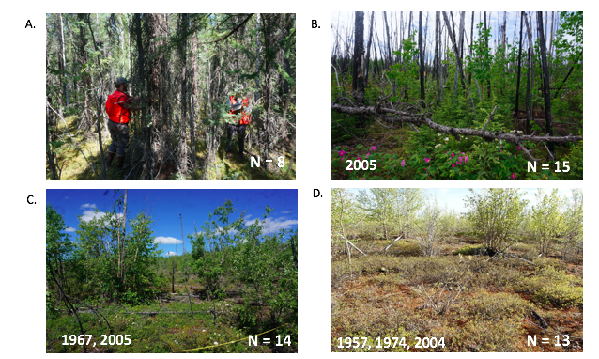

Figure 2

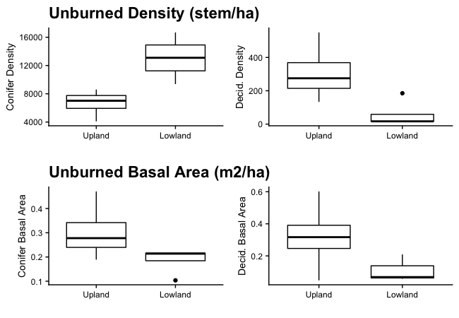

Figure 3

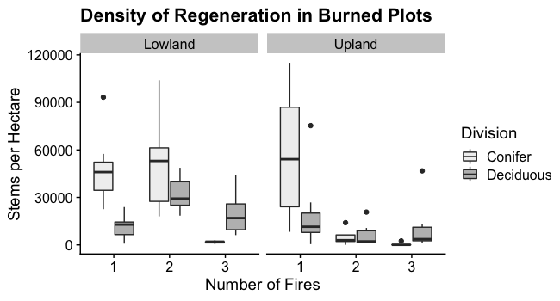

Figure 4

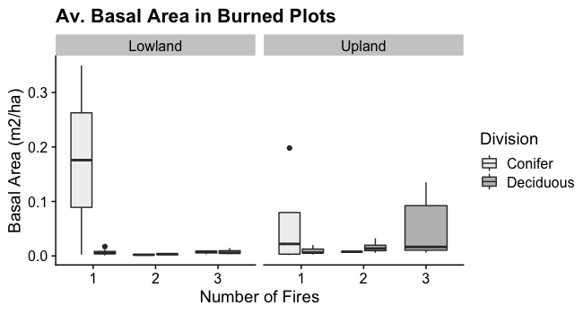Figure 5

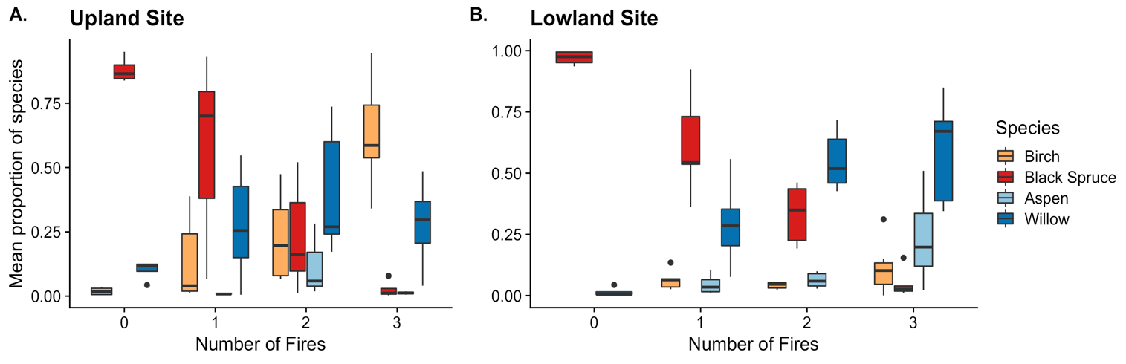

Figure 6

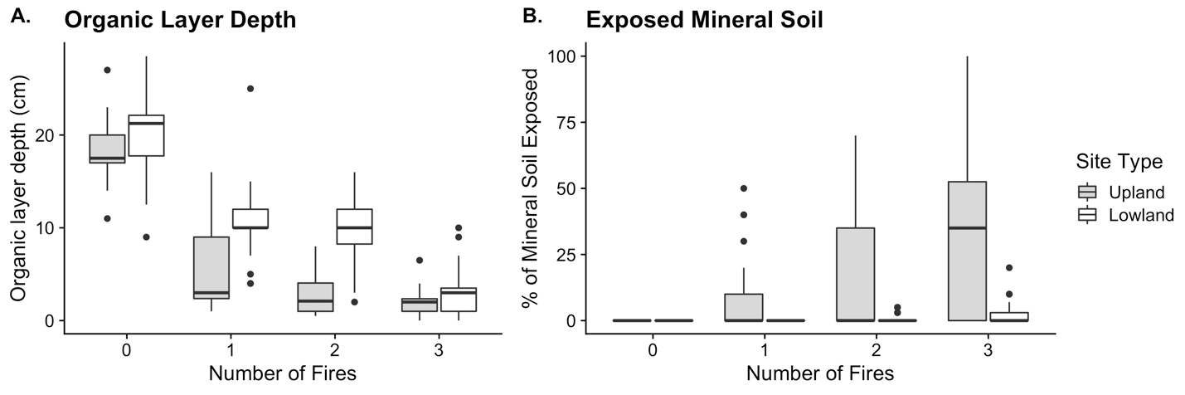

Figure 7